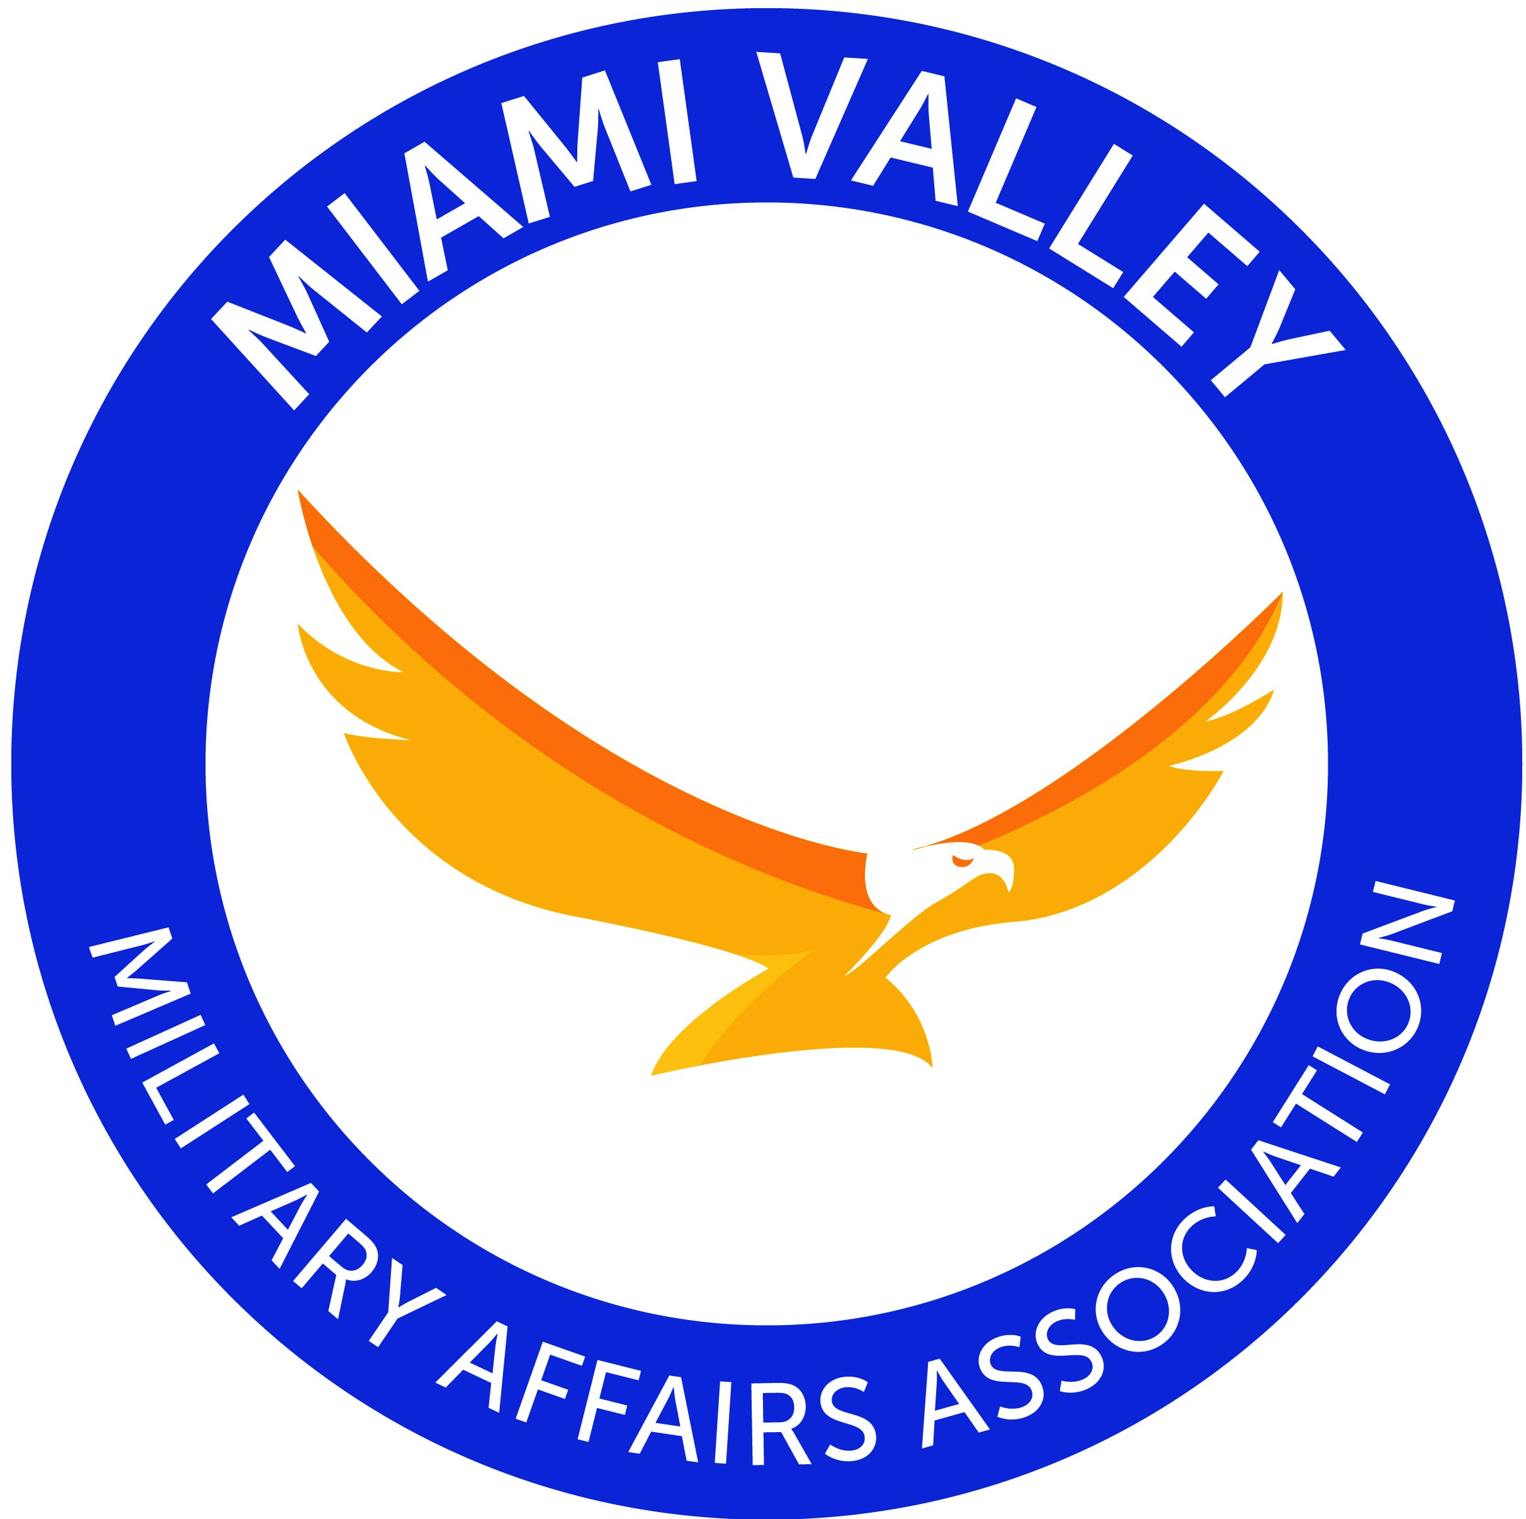

MVMAA BOARD OF TRUSTEES MEETING

13 April 2021
1800 hours/6:00 p.m.

Join the meeting: https://call.lifesizecloud.com/3533120
Call in by Phone : (877) 422-8614 Extension: 3533120#

AGENDA
6:00 1. PLEDGE OF ALLEGIANCE
6:03 2. INTRODUCTIONS
6:09 3. APPROVAL OF MINUTES
6:10 4. MISSION MOMENT
BASE COMMANDERS’ REPORTS
88 ABW - Col Patrick Miller/ Col Michael Phillips/ CMSgt Jason Shaffer
178 Wing - Col Kimberly Fitzgerald/ Col Mark Johnson/ CMSgt Scott Ross
445 AW - Col Raymond Smith, CMSgt Chris Williams
5. LIASIONS REPORTS
FIRST SERGEANTS ASSOCIATION – MSgt Jason Jukes
FISHER NIGHTINGALE HOUSE – Chris Stanley
USO – Erik Oberg
6. PRESIDENT’S REMARKS
7. CHAMBER REPORTS
Beavercreek (Brian Jarvis)
Bellbrook (Holly Beard)
Dayton (Woody Stroud)
Fairborn (Paul Newman, Jr.)
Huber Heights (Mark Bruns)
Kettering/Moraine/Oakwood (Anthony Colussi) /
Lewisburg (Dennis Roberts)
Northmont (Cathy Hutton)
Riverside (Sara Lommatzsch)
South Metro (Dwayne Adams)
Springfield (Bernie Willis)
Spring Valley (Judy Madden)
Trotwood (Marie Battle)
Vandalia-Butler (Will Roberts)
Waynesville (Rick Whitaker)
Xenia (Steve Brodsky)
Yellow Springs (Alexandra Scott)
8. COMMITTEE REPORTS
Military/Family Outreach – John McCance
Association Special Events – Candy Prystalowski
Marketing/Communication – Ralph Anderson
Nominating – Dan Semsel
Finance – Steve Goeman
MVMAA Foundation – Steve Goeman
Membership/Recruitment –Cassie Barlow
Golf – Holly Beard
9. UNFINISHED BUSINESS
10. NEW BUSINESS
7:15 11. ADJOURN
NEXT MEETING 11 May 2021 6:00 pm

